Jerry Wolfe Named “Beloved Man” by Eastern Band of Cherokee Indians
Cherokee, NC -- EBCI tribal elder Jerry Wolfe serves the people of the Eastern Band of Cherokee Indians every day of his life. A fluent speaker and traditionalist, he is always willing to share his knowledge of the Cherokee culture.
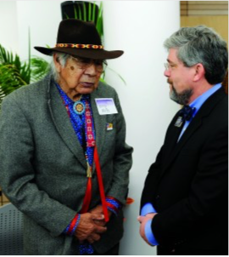
EBCI tribal elder Jerry Wolfe (left), who delivered a blessing in his native Cherokee language at the dedication ceremony for WCU’s new Health and Human Sciences Building on Thursday, Feb. 28, chats with Brian Railsback, dean of the WCU Honors College (WCU photos)

(MORE)

Due to his self-sacrifice and willingness to serve, Wolfe has been given the title of Beloved Man of the Eastern Band of Cherokee Indians, a designation that hasn’t been made to a man since the early 1800s.
“It’s an honor,” said Wolfe. “It’s a great honor.”
Tribal Council approved Wolfe unanimously as a Beloved Man during its regular session on Thursday, April 11.
“I think our old ways are so important,” said Big Cove Rep. Bo Taylor who originally submitted the resolution (the resolution was amended to state it was submitted by Tribal Council as a whole to show their unanimous support). “We talk about some really important issues. We talk about gaming. We talk about buying other land, but one thing that we need to remember is that the reason we sit here is because we are Indian people. We haven’t had this in a long time. It’s been many, many years since we’ve honored our elders in this way.”

(MORE)

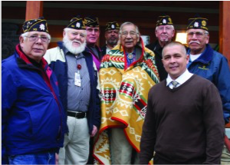

Jerry Wolfe (center in blanket), an EBCI tribal elder from the Yellowhill Community, was honored in Tribal Council on Thursday, Feb. 14. Wolfe was honored as a World War II veteran and Cherokee traditionalist at the USET Impact Meeting held in Washington earlier this month. He was unable to attend the event, and several Tribal Council representatives accepted a Pendleton blanket on his behalf. Wolfe was presented with that blanket on Thursday. He is shown here on Thursday with members of the Steve Youngdeer American Legion Post 143 and Principal Chief Michell Hicks (front row right).
Rep. Taylor said he has known Wolfe all of his adult life. “He has been nothing but a good person and served this community. I know it’s never been done before in the modern era, but I hope that we would take the time to remember who we are, as Indian people, and this is what we do.”
“I can’t think of anyone that deserves this honor more than Jerry Wolfe.”
Prior to the passage of the resolution on Thursday, Russell Townsend, EBCI Tribal Historic Preservation Officer, gave a brief history of the title of Beloved Man throughout history.
(MORE)

“In 1785 (Treaty of Hopewell), Benjamin Hawkins recorded for Andrew Pickins that the Cherokee showed up in great numbers with their women and children, and they allowed their Beloved Men and Women to speak,” he commented. “Among those Beloved Men and Women who spoke were Corntassel, or Longtassel, and Nancy Ward, Beloved Woman. So, we know in 1785 that the term was used, and it was used throughout the 1700s.”
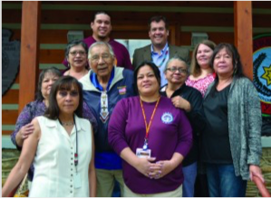
Beloved Man Jerry Wolfe (2nd from left, middle row) is shown with many members of his family on Thursday, April 11 after Tribal Council passed legislation making him the first Cherokee Beloved Man since the early 19th Century. Shown (left-right) front row – Carol Bradley Long (niece), Gerri W. Grady (daughter), Mara Nelson (niece), Roseanna Belt (niece), Vangie W. Stephens (daughter); middle row – Sarah Sneed (niece), Wolfe, Beth Bradley (niece); back row – Jake Stephens (grandson) and Brandon Stephens (grandson).
(Photo courtesy of Brandon Stephens)
Townsend went on to say, “These were people who were more important than Chiefs and more important than headmen of a particular community. They were respected throughout the Cherokee world.”

(MORE)

Barbara Duncan, Museum of the Cherokee Indian education director, also spoke of the history of the Beloved Man. “Throughout the 1700s, whether the Cherokees were at treaty negotiations or at the colonial capitals of Charleston and Williamsburg, they talk about the Beloved Men and the Beloved Women. They were, as Timberlake says, ‘warriors who were too old for them to go to war anymore, but who were valued by the Tribe for their service to the Tribe’.”
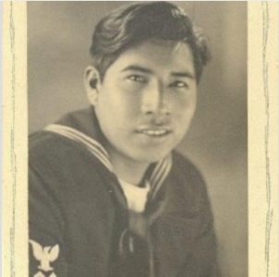
Jerry Wolfe served in the U.S. Navy during World War II. (Photo courtesy of Wolfe Family)
Duncan said that in addition to living a life of service, they were also respected for their integrity and good character. She said the last recorded instance she could find of a Beloved Man was Little Turkey who died in 1801.
(MORE)

Yellowhill Rep. B. Ensley spoke highly of Wolfe, “There’s not a better respected man in Cherokee.”
Myrtle Driver is a Beloved Woman of the Eastern Band of Cherokee Indians and serves as a Cherokee language translator for the Tribal Council and the Kituwah Academy. “Oftentimes, we may come across a word that we don’t remember or we need to know something about our history or our culture, and we can always go to Jerry, and he is always more than willing to help us. And, I really do appreciate all that Jerry Wolfe has given us.”
Painttown Rep. Tommye Saunooke commented to Wolfe, “Now, you join the ranks of Nancy Ward, Maggie Wachacha, Lula Gloyne, Louise Maney and Myrtle Driver.”
In addition to his service to the Tribe, Wolfe was a World War II veteran having served in the U.S. Navy. He has been honored by many organizations and received many honors over the years for his cultural knowledge. In 2003, he received the North Carolina Folk Heritage Award and in 2010, he received the Brown-Hudson Folklore Award from the North Carolina Folklore Society.

###

